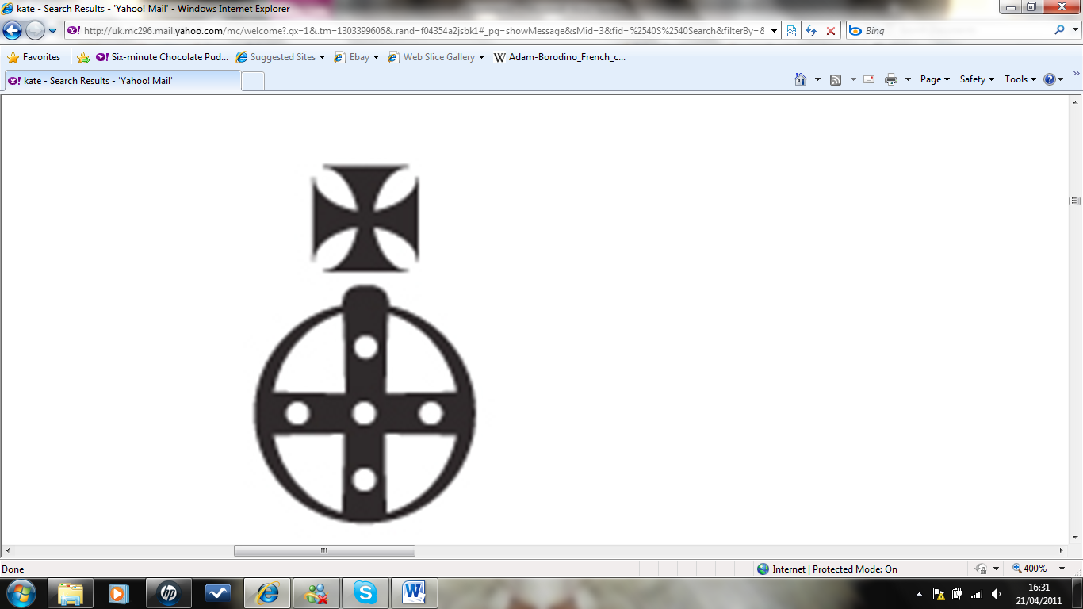
Katie Reay Scott
Hair & makeup artist

KATIE REAY SCOTT
Hair & Makeup Artist

