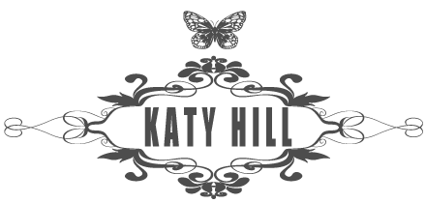

I was recently asked to do the hair and makeup for KATY HILL T.V & RADIO PRESENTER, BLOGGER & SUPER MUM.

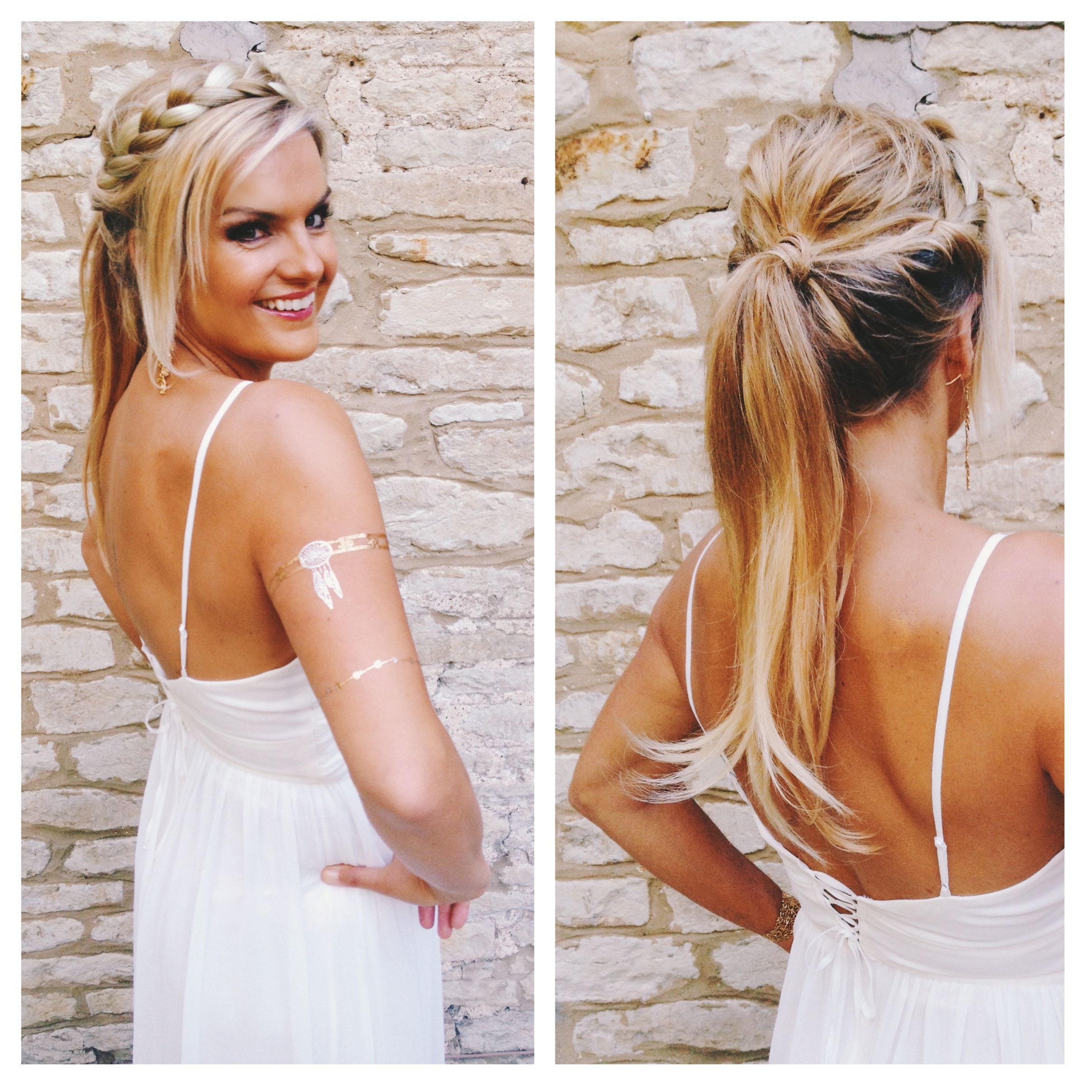

She was attending a black tie ball with a game of thrones theme. Take a look at her blog here and see how we transformed her!

http://katyhillsblog.com/2015/08/08/being-cinders/

