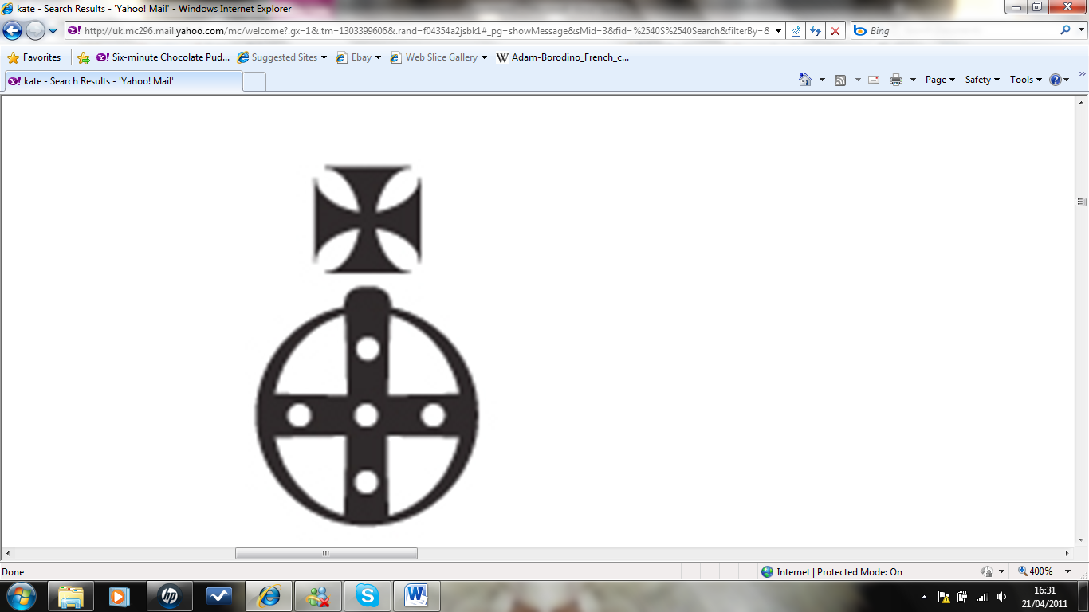
KATIE REAY SCOTT
Hair & Makeup Artist

